SpeechWire Electronic Balloting
Judges can access ballots by going to the SpeechWire e-balloting website, which is at:
ballots.speechwire.com
There, type in your SpeechWire account email address and password. For coaches, this is the same as your SpeechWire coach account. If this is the first e-ballot tournament you are judging, you should have received a password in an email recently.
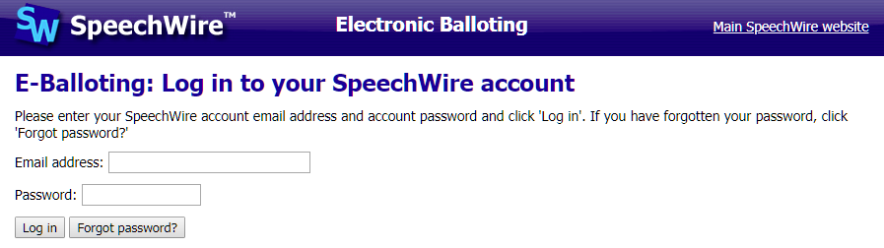
Once you log in, you’ll see your current ballots. You should be notified by email - and by text message if you subscribe at www.speechwire.com/live - when you are assigned ballots.
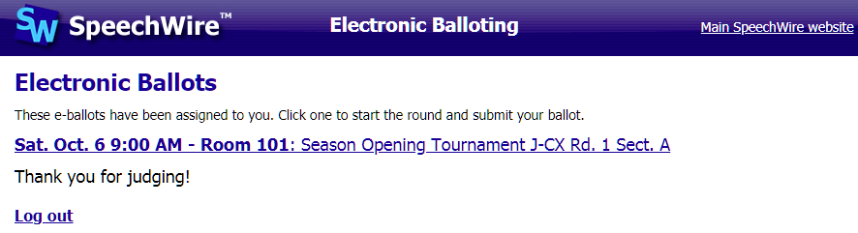
Click or tap the round that they are currently judging. You may be asked for a contact phone number the first round you judge at the tournament. Then you will see a big link to click to notify tab that you have started the round. Click it once the debaters are present and debate is starting.
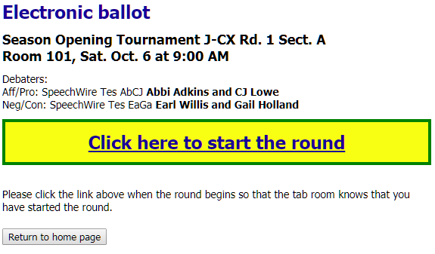
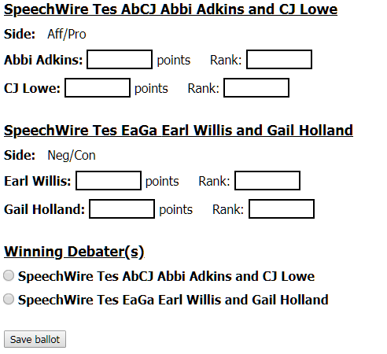
After starting the round, you’ll see the e-ballot. It will have some or all of the tools pictured at left. Your tournament may or may not collect ranks -- and you may also need to denote which team was on which side (especially in Public Forum debate).
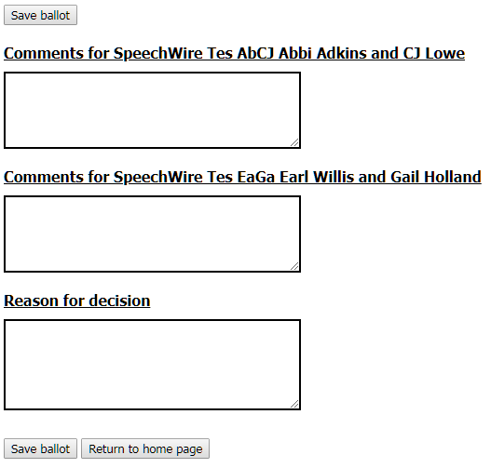
You will enter the points for each speaker, along with their rank (if applicable). You will also mark the winning debater and then click 'Save ballot'. This will lock in the debate result. You will not be able to change it once submitted -- if they make an error, consult with the tab room to have the tab room change it.
Below the decision portion of the ballot are boxes for a reason for decision as well as comments for each side in the debate (see at right). You can go back into the comments and add more after you submit the decision and points, so please be sure to submit your decision and points as soon as possible once debate ends so that tab can schedule the next round. You can finish your comments later by reopening the ballot.

