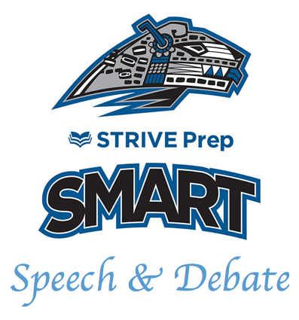
SMART Academy
Invitational

Dear coach,

You are cordially invited to the SMART Academy Invitational at Strive Prep – SMART Academy on November 23, 2019. This is our fourth year hosting a tournament and we are very excited for many of you to join us for a day of fun and competition.

NIETOC: This year we are proud to announce that we are a bid tournament to the National Individual Events Tournament of Champions (NIETOC). Also known as the Speech Tournament of Champions. Bids can be earned in the following events: HI, DI, Duo, POI, OO, INF, and Extemp.

Based off last year’s numbers, students who finaled in OO or placed in the top 3 in the other events would have earned a bid. The SMART Academy Speech & Debate team has attended this national tournament in May every year for the last three years. If you have any questions about the tournament experience, I would be happy to answer them.

Doubling: Debaters may not enter more than one event. Speech competitors may enter up to 4 events. Coaches know if your student can handle 3 events in the same flight or not, so that is your call. Extempers who double enter risk losing prep time. Congress students may enter 2 speech events in the A flight.

Flight A: OO, POI, DUO, IX, USX

Flight B: HI, DI, POE, INF, Cong.

Debate: CX, LD, PF

Schedule: Flight A Flight B Debate
(OO, POI. DUO, IX, USX) (HI, DI, PI, INF, Cong.) (CX, PF, LD)
7:45: IX/USX Draw 8:00 Round 1
8:00: Round 1A 9:30: Rd. 1B 10:30 Round 2
11:00: Round 2A 12:30: Rd. 2B 1:00 Round 3
2:00: Round 3A 3:30: Rd. 3A 3:30 Debate Finals
4:00: A Finals 5:00: B Finals

6:30: Awards
Fees and Payment: The entry fee is $8 an entry for Congress. $10 per student in speech events. $20 per CX, PF, and Duo team. $12 per LD entry. (We are paying debate judges $15 a round, which is why the $2 increase in LD.)

Please make checks payable to “Strive Prep Smart” IMPORTANT: Please send checks to 3201 W. Arizona Ave “ATTN: SMART/GRANT THOMAS”. This will help keep checks from floating around and mystery money remaining in your account.

Judging: Tournaments need judges. Due to the language backgrounds of our families we cannot turn to our families to provide as many judges as other schools. Each school is required to bring one judge for every 7 entries (Speech or Debate). There will be a $25 fee per missing judge. However, no school is asked to bring more than 4. So if you bring more than 28 total entries, you don’t need to bring more judges. Head coaches count towards a school’s judging requirements.

And of course, we will pay every judge (including the judges you bring) $10 a round for speech rounds and $15 a round for PF, CX, or LD.

“The Academy Award” & Team Awards: We will be recognizing “The Academy Award for Best Speaker” to the speech student who performs the best that day based off the number of times they appear in finals and how they place within said finals. “The Academy Award for Best Debater” will go to the debater from any of the three debate events with the highest speaker points. Team awards will be given to the top three "large entry" teams and the top three "small entry" teams. What division teams are divided into will be determined after registration is finalized.

Site: Please note, there are many “Strive Prep’s”. Simply googling “Strive Prep” may take you to one of our middle schools. Please make sure your students, parents, and judges have the address listed below to ensure they arrive at the right site.

The tournament will be held at Strive Prep SMART Academy High School, 3201 W Arizona Ave, Denver, CO 80219. Please park in the parking lot on the west side of the school (along Irving street). Google Maps might say that address is “Strive Prep Westwood”. That is the name of the middle school we share our campus with.
---------------------------------------------------------------------------------------------------------------------
Hosting this tournament is a tremendous source of pride for my students, my colleagues, and our community. Additionally, this tournament would not be possible without the work of so many in the speech and debate community. Your attendance and contributions to this tournament are truly appreciated.

Best,
Grant Thomas
Strive Prep SMART Academy

