ROUND 1
No parent wants their child called out on Halloween for being culturally offensive.
Google tells us many search to learn whether the costume their child wants to wear might be racist or insensitive. Many of us moms and dads grew up wearing Native American head dresses and Geisha garb and didn't hear boo about it. Sadly.
Now, headlines scream about whether it's OK to go door to door dressed as Moana or Aladdin. Well, is it?
We turned to Neal Lester, Arizona State University Project Humanities director, who has led countless discussions on cultural appropriation to answer that.
Cultural appropriation, simply put, is "taking elements of someone else's culture without permission," Susan Scafidi, author of “Who Owns Culture: Appropriation and Authenticity in American Law," previously told USA TODAY.
Use that bump as an accessory: 8 adorable and funny ways to dress up your pregnant bump for Halloween
A dose of pure joy: These cute Halloween pet costumes are everything we need right now!
Halloween is a land mine of cultural appropriation examples for parents because, Lester said, “it’s easy to see Disney characters and cartoon character animations and imagine those costumes are safe.”
They can be. But recent years tell us they aren’t always.
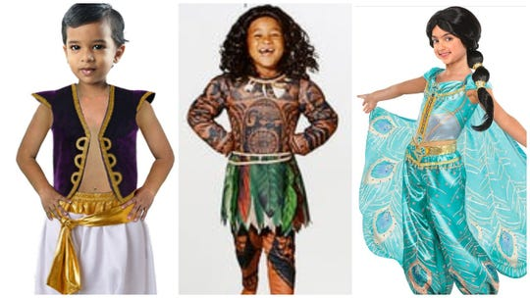
Halloween can be a tricky time for parents as they figure out what costumes are OK and what costumes will cause offense to someone else's culture. (Photo: Spirit Halloween/AP/Party City)

Recent examples of cultural appropriation
Moana costumes have been fiercely debated since the movie’s 2016 debut. Some Polynesian and non-Polynesian groups took issue with dressing up as the female lead.
Auli’i Cravalho, the Hawaii-born actress who voiced the title character, said last year that she had no problem with fans of all ethnicities dressing as her character for Halloween.
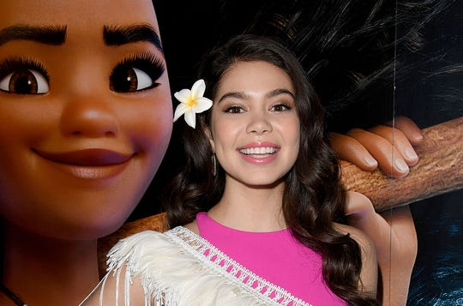
Auli'i Cravalho, the actress who voiced Moana in the hit Disney film, said it's OK for people to dress up as her character for Halloween. (Photo: Stuart C. Wilson, Getty Images for Disney)
However, Disney pulled its Maui costume two years earlier that featured a long-sleeved brown shirt with tattoos like those worn by Polynesian chiefs. The costume received international condemnation.
The costume’s trouble is with the change of skin color and its markings, Lester said. People didn't understand the culture that those tattoos represent and "you’re literally wearing someone else’s identity.”
Over the years, other Halloween children’s costumes were also recognized as either racist or insensitive including a prisoner, a hobo, a ninja, Day of the Dead representations, a Native American and Pocahontas.
And with movies like "Black Panther" and "Coco" leading to more culturally diverse costumes, some parents fear wearing the costumes. Other parents are wondering whether it's OK for their kids to wear them.
“I would say this isn’t a universal question some parents are asking, this is a question that white parents are asking,” Lester said.
Cultural appropriation Q&A: Is it OK for a white kid to dress up as Moana for Halloween?

Details matter in popular kids' costumes
Let's get down to it. Lester doesn't like lists, but if your Halloween costume includes any one of these popular Disney princesses or characters, he offers what mostly amounts to common sense.
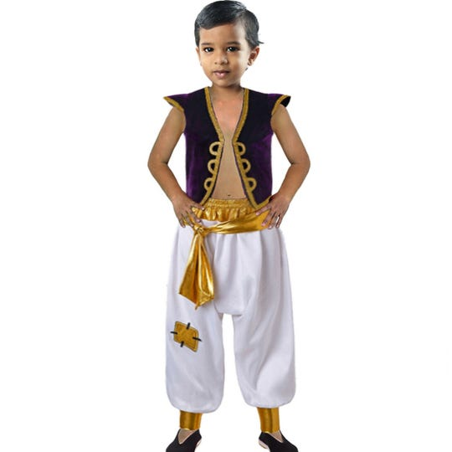
This Aladdin-like costume sold Spirit Halloween has some parents wondering, is this OK for my child? (Photo: Spirit Halloween)
Parents should be careful with these costumes:
- Aladdin, the street urchin turned prince thanks to a genie and Disney movie of the same name.
- Princess Jasmine, independent and determined to marry someone she loves in Disney’s "Aladdin."
- Princess Tiana, the determined waitress who kisses a frog who becomes a prince again and turns her into a princess.
- Mulan, who disguises herself as a male to fight in an army and protect her sick father.
- Black Panther, the Marvel comics superhero and one of the Avengers.

ROUND 2

How Americans Became Convinced Their Halloween Candy was Poisoned
These chilling candy poisonings might make you rethink trick-or-treating.
ERIN BLAKEMORE

Rumors of tainted, poisoned or otherwise murderous Halloween candy handed out to unsuspecting youngsters are as much a part of the Halloween tradition as costumes and sing-song pleas for sweets. The myth goes like this—no kid is safe on October 31 because psychotic murderers may hand out tainted treats to trick-or-treating children.
But is poisoned Halloween candy a terrifying threat or an urban legend?
“Many, if not most, reports of Halloween sadism are of questionable authenticity,” write sociologists and criminal justice experts Joel Best and Gerald T. Horiuchi.
When they conducted an extensive study on so-called “Halloween sadism,” or crimes specifically committed using Halloween treats or customs, they concluded that the threat is greatly exaggerated. Though both parents and kids are taught to be on the alert for tampered-with sweets, most of the cases the researchers analyzed were either overstated or could not be linked to Halloween itself.
Best and Horiuchi suggest that fears of Halloween sadism rise during fearful times. For example, paranoia about tainted candy spiked in the early 1980s after a rash of Tylenol poisonings in which cyanide-laced acetaminophen was placed on store shelves and sold. The high-profile crime led to the introduction of childproof containers and tough federal laws aimed at punishing those who tamper with drugs. After the Tylenol murders, which are still unsolved, warnings about adulterated Halloween candy increased.
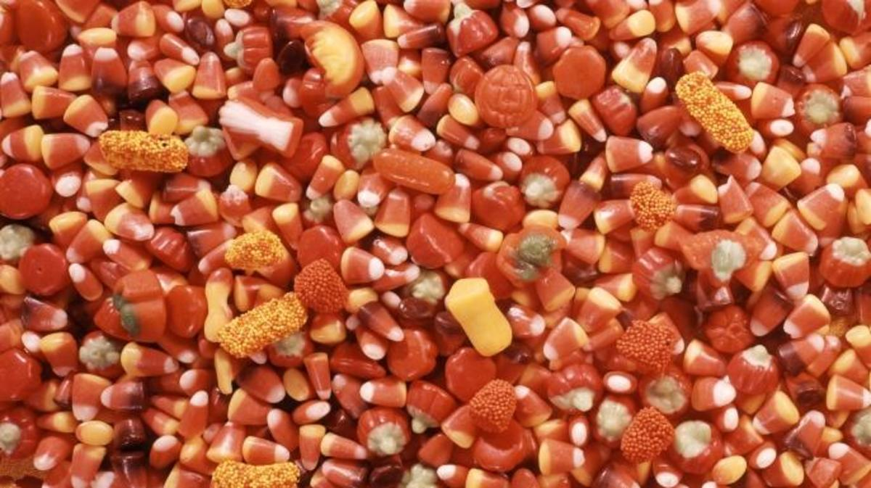
Halloween Candy Corn (Credit: H. Armstrong Roberts/Getty Images)
While the fears may be overblown, Halloween crimes involving poison have occurred.
In 1964, for example, a New York woman named Helen Pfeil was arrested for handing out things like ant poison and dog biscuits to kids. When questioned, the housewife said that she was joking and that she gave the items to kids she felt were too old to be trick-or-treating. Though no children were poisoned during the incident, law enforcement didn’t find her actions funny.
The most infamous Halloween poisoning took place on October 31, 1974. That’s when a Texas man named Ronald O’Bryan gave cyanide-laced pixie sticks to five children, including his son. The other children never ate the candy, but his eight-year-old son, Timothy, did—and died soon after.
Though nobody saw O’Bryan put the cyanide in the candy, investigators learned that O’Bryan had recently taken life insurance policies out on his children. He was convicted of murder and executed via lethal injection in 1984. Though it’s been decades since the crime, the “Candyman” murder still looms large in the memories of many parents on Halloween.
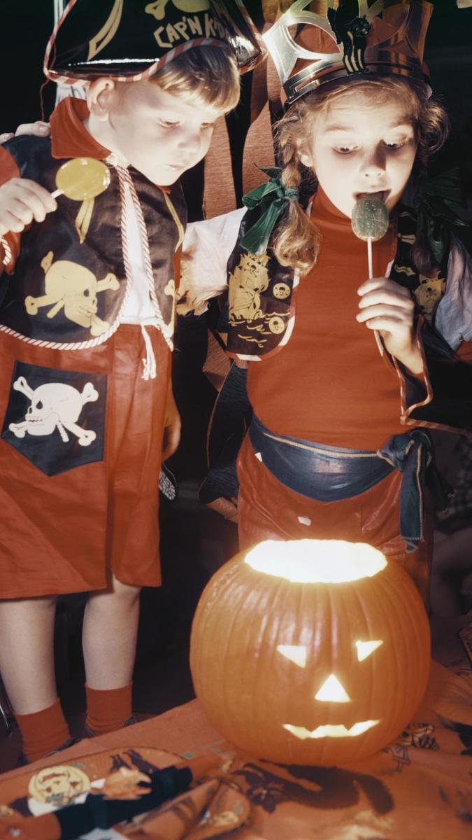
Children looking into glowing Jack-o-lantern. (Credit: Constance Bannister Corp/Getty Images)
“As you know,” O’Bryan’s attorney told the American-Statesman in 2009, “my client was convicted of killing Halloween.” But regardless of how horrific O’Bryan’s crime, it was no random act of Halloween havoc, since it was aimed directly at his children and their friends, not at trick-or-treaters.
Perhaps because of O’Bryan’s notoriety, parents can be still skittish when it comes to Halloween candy. Authorities can be, too—despite the fact that rumors of randomly distributed poison candy or threats like apples that contain razor blades are nothing more than urban legends.
For example, when a 7-year-old California girl collapsed while trick-or-treating on Halloween 1990, Santa Monica police confiscated kids’ candy. However, her illness was later discovered to be caused by a heart murmur and when examined, she showed no sign of poisoning.
The U.S. doesn’t have a monopoly on poisoned candy horror stories. In the 1980s, a crime ring called the “Mystery Man with 21 Faces” blackmailed Japanese candy companies with threats that it would lace their candy with cyanide if they didn’t offer large ransoms. At first, it seemed like just a threat, and stores pulled large amounts of candy from store shelves only to find that it was not poisoned.
The blackmailers struck again a few months later. This time, their threats were in earnest: Packs of cookies and candies laced with cyanide were discovered on store shelves in central Japan. Fortunately, nobody died from the poison—though the chief of the Shiga Prefecture police department eventually killed himself because of his failure to stop the crime ring.
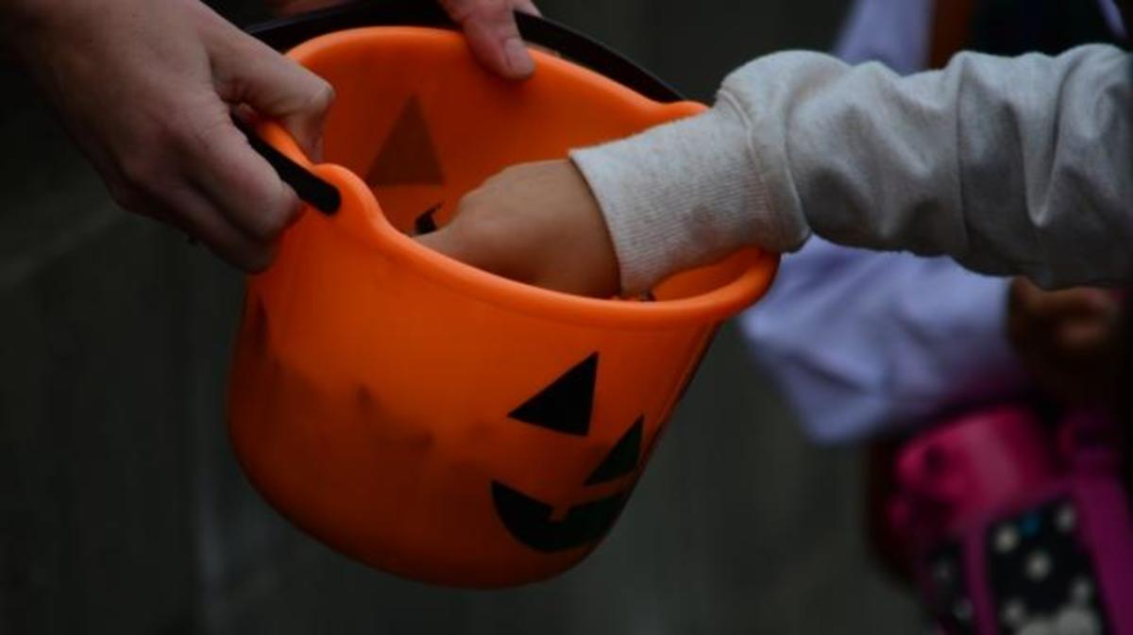
Child’s hand picking candy from a Halloween basket. (Credit: Oliver Kramm/EyeEm/Getty Images)
Who committed Japan’s candy crimes? We may never know. The perpetrators still haven’t been found—even after 125,000 investigations by Japanese police.
If you’re looking for something to fear on All Hallows’ Eve, you might want to look away from the treat bag and toward the nearest car. Halloween night can be deadly due to DUIs and pedestrian accidents. According to the National Highway Traffic Safety Administration, 43 percent of all Halloween fatalities between 2011 and 2013 involved a drunk driver.
Between careening cars, the poison-peddling housewife, the murderous dad and the mysterious ways of the Mystery Man, trick-or-treating may never seem sweet again.
BY
ERIN BLAKEMORE

When Does a Halloween Costume Cross the Line?
Making Halloween masks great again, at a store in Chicago in 2016. Related Article.CreditCreditScott Olson/Getty Images
By Michael Gonchar

Will you be dressing up this Halloween? How about your friends and siblings? What will you be wearing — and how did you decide what costume to wear?
How do you know when a Halloween costume crosses the line from being edgy or original to offensive?
In “Clowns, Candidates and Other Halloween Costume Missteps,” Christine Hauser writes:
In a matter of days, many Americans will find themselves facing an important but risky decision. No, not the election: What to wear for Halloween.
In a year of a bitterly divided presidential campaign, a growing divide on matters of race and gender and bizarre news events like creepy clown sightings, it seems harder than ever to find a costume that won’t get you into trouble.
Some cities have banned or strongly discouraged clown outfits, while costume sellers have faced protests from Native Americans, Muslim Americans and other groups about anything that mimics traditional ethnic or religious dress. The fall ritual of dress-up has particularly haunted American universities, where past problems have led to annual warnings about costume choices. Media outlets have a new October staple, helpful guides about what to avoid: generally anything involving blackface, Nazis, suicide bombers or the sexualizing of children.

