SpeechWire Electronic Balloting
Judges can access ballots by going to the email address that they used to create a SpeechWire when their son/daughter’s coach signed them up for the tournament.
OR
SpeechWire e-balloting website, which is at: www.ballots.speechwire.com
There, type in your SpeechWire account email address and password. For coaches, this is the same as your SpeechWire coach account. If this is the first e-ballot tournament you are judging, you should have received a password in an email recently.
Once you log in, you’ll see your current ballots. You should be notified by email - and by text message if you subscribe at www.speechwire.com/live - when you are assigned ballots.
Click or tap the round that they are currently judging. You may be asked for a contact phone number the first round you judge at the tournament. Then you will see a big link to click to notify tab that you have started the round. Click it once the debaters are present and debate is starting.
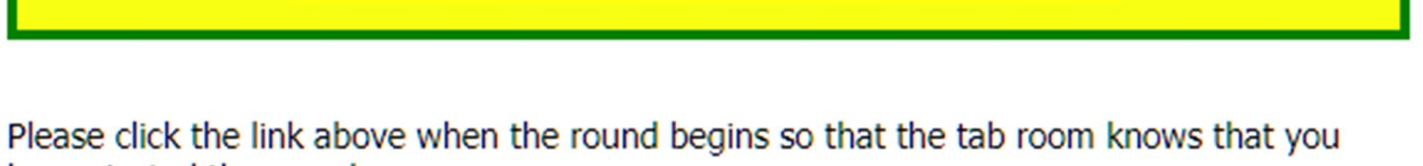
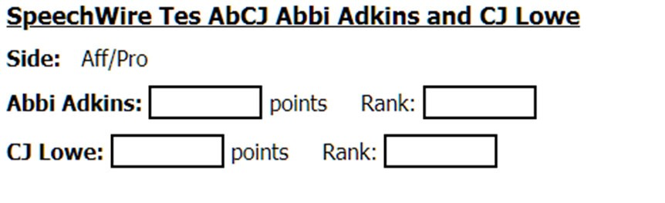
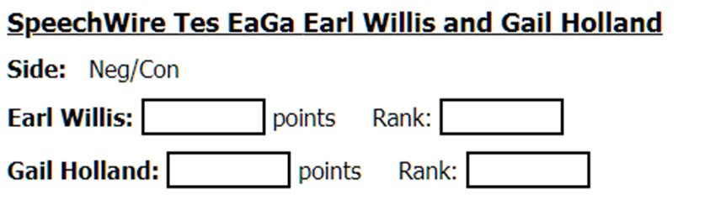
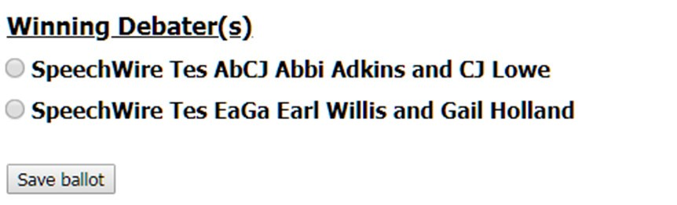
After starting the round, you’ll see the e-ballot. It will have some or all of the tools pictured at left. Your tournament may or may not collect ranks -- and you may also need to denote which team was on which side (especially in Public Forum debate).
You will enter the points for each speaker, along with their rank (if applicable). You will also mark the winning debater and then click 'Save ballot'. This will lock in the debate result. You will not be able to change it once submitted -- if they make an error, consult with the tab room to have the tab room change it.
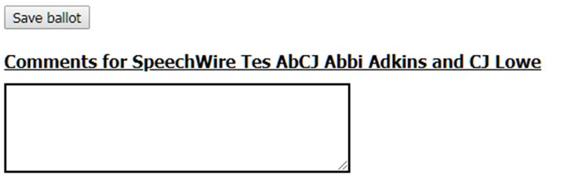
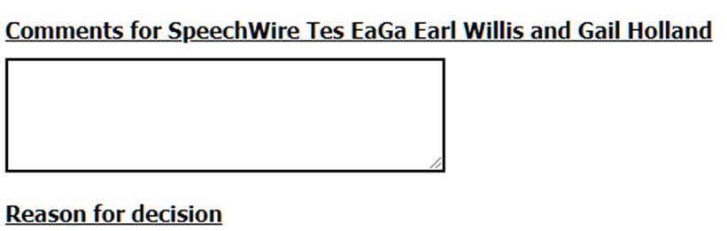

Below the decision portion of the ballot are boxes for a reason for decision as well as comments for each side in the debate (see at right). You can go back into the comments and add more after you submit the decision and points, so please be sure to submit your decision and points as soon as possible once debate ends so that tab can schedule the next round. You can finish your comments later by reopening the ballot.

SpeechWire EBalloting BEFORE and DURING the Tournament:
FOR COACHES: Creating student accounts in SpeechWire
 | SpeechWire now offers student accounts, which are created by head coaches so that their students can compete in live synchronous tournaments on some video platforms, and so that students can review feedback from their electronic ballots after any tournament that used electronic ballots. This video details how head coaches create student accounts as part of their overall school account, and what student accounts can be used for.  Watch 'Creating student accounts in SpeechWire' on YouTube
FOR JUDGES: Judging tournaments using SpeechWire's electronic ballots
 | Are you a judge who is set to judge a tournament on SpeechWire soon using electronic ballots? If you are judging a virtual tournament - it is definitely going to be using electronic ballots. Or are you a coach who wants to share some more information with your judges about SpeechWire's electronic ballots? Send this video their way. The video talks about speech, debate and congress e-ballots, as well as how they integrate with various asynchronous/synchronous tournament approaches.  Watch 'Judging Speech and Debate on SpeechWire with Electronic Ballots' on YouTube
FOR STUDENTS: Competing in live online tournaments at live.speechwire.com
 | Students can participate in tournaments being run in conjunction with SpeechWire on a variety of synchronous platforms via their live.speechwire.com student accounts (once their coach has created their account). This video details using live.speechwire.com to participate in live online tournaments on a variety of platforms.  Watch 'Competing in Virtual Tournaments on SpeechWire' on YouTube

SpeechWire EBalloting AFTER the Tournament:

FOR COACHES: Managing your team's electronic ballots on SpeechWire
 | After a tournament, you can view your team's electronic ballots in PDF form via your SpeechWire coach account. You can also choose to screen the electronic ballots before they are released to your students; you can choose which tournaments' ballots to release to your students; and you can block or 'lose' individual electronic ballots if you see fit. This video details how to configure how electronic ballots are handled for your team and how to view your students' e-ballots after a tournament.  Watch 'Managing your team's electronic ballots on SpeechWire' on YouTube
FOR STUDENTS: Viewing electronic ballots after a tournament
 | Following completion of a tournament, students can view feedback from judges by viewing electronic ballots in their student account. This video details how to view the electronic ballots in a student account and the process by which the electronic ballots are released and arrive in the student accounts so that students can see them.  Watch 'Viewing your electronic ballots on SpeechWire' on YouTube

