EARL WELLS VIRTUAL SPEAKEASY
OREGON STATE UNIVERSITY
DAVE LOMBARDO
First Place
Heavy Metal Drumming
December 6-7, 2025
Corvallis, Oregon



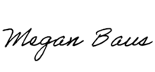
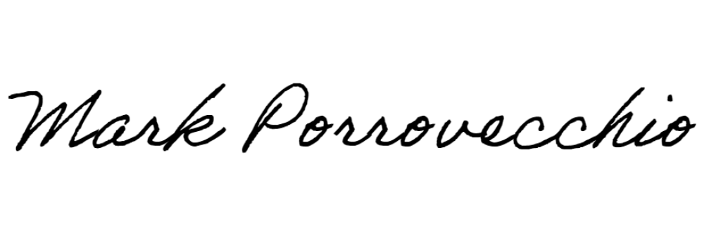

Mark Porrovecchio, Director |  | Megan Baus, Assistant Director

